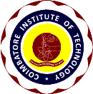
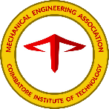
COIMBATORE INSTITUTE OF TECHNOLOGY
(AN AUTONOMOUS INSTITUTE AFFILIATED TO ANNA UNIVERSITY)
COIMBATORE-14
MECHANICAL ENGINEERING ASSOCIATION
MECHNOTRON 2021
WEBINAR REPORT
Faculty Advisors:
Dr. M. Velliangiri,
Assistant Professor,
Depaertment of Mechanical Engineering.
Mr. M. Karthikeyan,
Assistant Professor,
Department of Mechanical Engineering.
Mr. D.P. Sam Solomon,
Assistant Professor,
Department of Mechanical Engineering.
Mechnotron Main Committee:
Gokul Krisnaa N (1802013) - Chairman
Rajeshkumar S (1802108) - Secretary
Sunder Rajan A (1802057) - Secretary
Pugazhendhi R (1802043) - Joint Secretary
Raja K (1802107) - Joint Secretary
Dinendra A V (1802009) – Treasurer
Webinar Managers:
Mathan S (1802029)
Mohammed Imran S (1802095)
Pradeep S G (1802041)
Rajasekar U (1802045)
Dharani Dharan A D (1802008)

On account of Mechnotron 2021 Students of Mechanical Engineering Association, Department of Mechanical Engineering, Coimbatore Institute of Technology, Coimbatore organized two online webinars namely Advanced driver assistance systems in modern cars and Advancement in 3D printing, Zero gravity 3D printing, and futuristic 4D printing held on 13th and 14th of March 2021 under the guidance of Dr.M.Velliangiri, Mr.M.Karthikeyan and Mr.D.P.Sam Solomon in Microsoft Teams platform.

Day | Date | Topic | No. of participants
1 | 13/03/2021 | Advanced driver assistance systems in modern cars | 264
2 | 14/03/2021 | Advancement in 3D printing, Zero gravity 3D printing, and futuristic 4D printing | 254
WEBINAR DAY 1:

Topic: Advanced driver assistance systems in modern cars
Resource Person: Mr. P. Saravanan, Master Technician Skoda SGA Cars India Pvt. Ltd., Coimbatore
Date: 13/03/2021
Time: 11 AM to 12.30 PM

- Skoda, a premium Czech company founded in 1895 with products selling over 100 countries is a flag bearer of top-notch German technology known for precision manufacturing in utmost quality.
- SGA Skoda cars in Coimbatore is Asia’s largest service center and India’s first digital showroom.
- The resource person listed the various features of ADAS vehicles sequentially along with the levels of Automation.
- The examples given were very much relevant with the topic.
- After the completion of the lecture, the Q/A session was done through the chat window. The participants were curious in raising questions to the resource person.

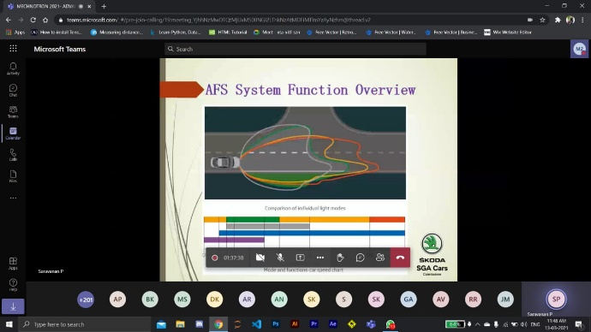

FEEDBACK FROM PARTICIPANTS:

In the Webinar we have got many positive feedbacks like

- Learned something new through the session

- The webinar went pretty good and I hope more session and webinars will be offered from your college

- It was a good and informative session

- Nice and good session with good teaching

- Learned more about features of ADAS

WEBINAR DAY 2:

Topic: Advancement in 3D printing, Zero gravity 3D printing, and futuristic 4D printing
Resource Person: Mr. E.P. Mohammed Basheer, Managing Director, iNSTA3D Technologies, Coimbatore
Date: 13/03/2021
Time: 11 AM to 12.30 PM

- iNSTA3D Technologies through the aid of advanced 3D printing technology they are developing the next generation project of innovation through their contribution in automotive, medical, industrial, architectural, engineering and education.
- He listed the application of 3D printing in various fields and the need for 4D printing in medical sciences.
- Besides that, he included NASA’s zero-gravity 3D printing in space for making tools.
- After the completion of the lecture, the Q/A session was done through the chat window. The participants were curious in raising questions to the resource person.

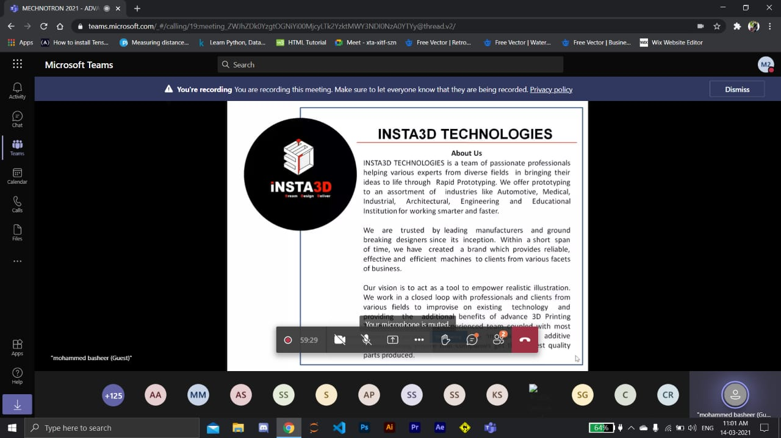

FEEDBACK FROM PARTICIPANTS:
The feedback from the 3d printing webinar are as follows with great response from the attendees such as
- Very nice and wonderful session

- It was really informative and was also interesting, thank you for conducting this webinar.
- It was very useful session, I gained a lot of information about 3D printing

- Very much satisfied with the webinar

- Innovative session

